E-Commerce Sales

1. What is the region-wise sales?

SELECT Region , SUM(Sales) AS Total_Sales FROM Ecommerce_Sales_Data_2024_2025 GROUP BY Region;

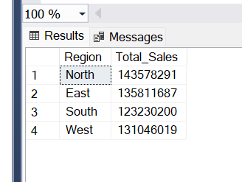

2.What is month-wise sales ?

SELECT YEAR([Order Date]) AS Year, MONTH([Order Date]) AS Month, SUM(Sales) AS Total_Sales FROM Ecommerce_Sales_Data_2024_2025 GROUP BY YEAR([Order Date]), MONTH([Order Date]) ORDER BY Year, Month;

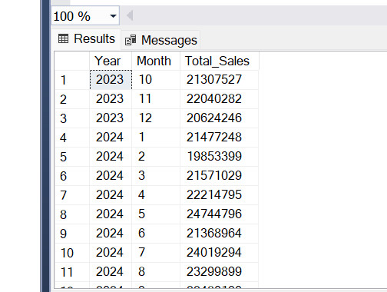

3.What is quarter-wise sales ?

SELECT YEAR([Order Date]) AS Year, DATEPART(QUARTER, [Order Date]) AS Quarter, SUM(Sales) AS Total_Sales FROM Ecommerce_Sales_Data_2024_2025 GROUP BY YEAR([Order Date]),DATEPART(QUARTER, [Order Date]) ORDER BY Year, Quarter;

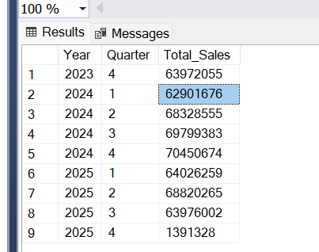

4.What are top 5 categories getting profit?

SELECT TOP 5 Category, SUM(Quantity) AS TotalQuantity, SUM(Profit) AS TotalProfit FROM Ecommerce_Sales_Data_2024_2025 GROUP BY Category HAVING SUM(Profit) > 1000000 ORDER BY TotalProfit DESC;

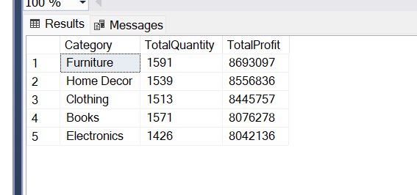

5.What are bestselling subcategories of each category and what are their total sales?

SELECT Category, [Sub Category], TotalSales FROM ( SELECT Category, [Sub Category], SUM(Sales) AS TotalSales,ROW_NUMBER() OVER (PARTITION BY Category ORDER BY SUM(Sales) DESC) AS rn FROM Ecommerce_Sales_Data_2024_2025GROUP BY Category, [Sub Category]) t WHERE rn = 1;

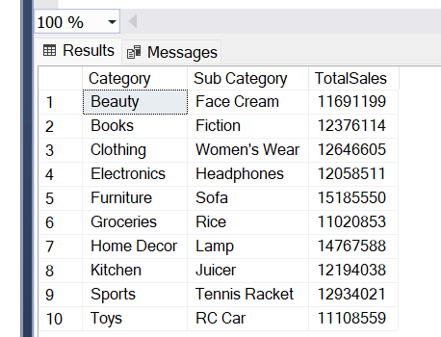

6.What is quantity sold and sales done by different payment modes?

SELECT [Payment Mode], SUM(Quantity) as Total_QuntitySold , SUM(Sales) as TotalSales FROM Ecommerce_Sales_Data_2024_2025 Group By [Payment Mode] Order By TotalSales desc

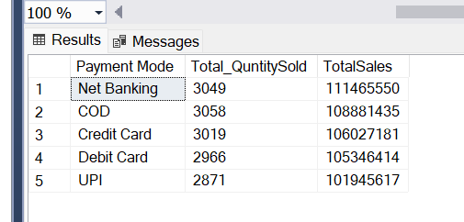

7.What is average discount on each category?

SELECT Category , AVG(Discount) AS Avg_Discount FROM Ecommerce_Sales_Data_2024_2025 GROUP BY Category Order By Avg_Discount DESC;

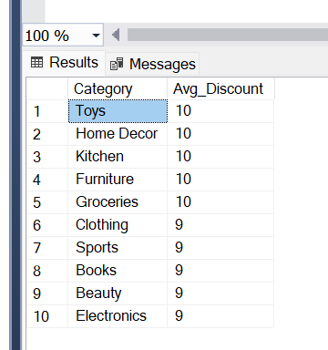

8. What are the region and city-wise sales?

SELECT Region, City , SUM(Sales) as TotalSales FROM Ecommerce_Sales_Data_2024_2025 GROUP BY Region, City Order By Region, TotalSales desc;  
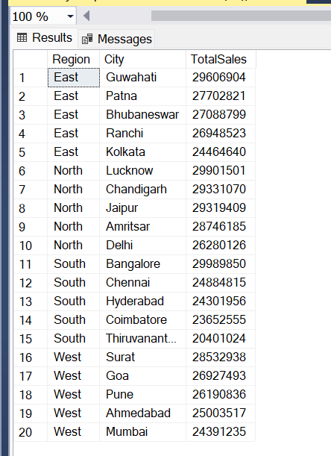

9.What 10 sub categories have maximum unit price?

SELECT Top 10 Category,[Sub Category], MAX([Unit Price]) AS Highest_Unit_Price FROM Ecommerce_Sales_Data_2024_2025 GROUP BY Category, [Sub Category] ORDER BY Highest_Unit_Price DESC;

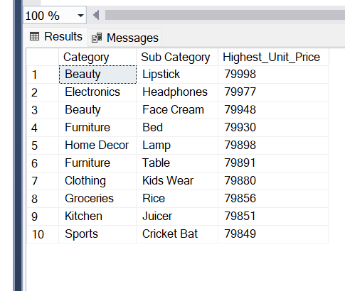

10.What is the average quantity ordered for each category?

SELECT Category, AVG(Quantity) AS AvgQuantity FROM Ecommerce_Sales_Data_2024_2025 GROUP BY Category ORDER BY AvgQuantity DESC;

